Climate Change and NIMBY in your Community

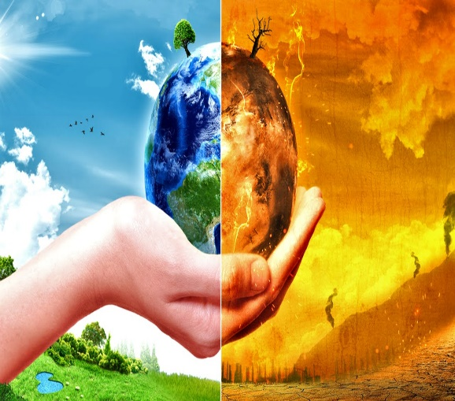
Find three (3) news articles about climate change within the last two years. Summarize the articles and their impact. Cite and reference the articles in APA on the References page of the document.
Climate change in the news
What are the main impacts of climate change?

What can the community do to slow down the effects of climate change?

Explain NIMBY. What evidence of NIMBY is present in your community? Where are the water treatment plant, landfills, or power plants located?

Find a lake, pond, or river in your community. Take a picture of its conditions. Describe the conditions. Is there any pollution? Is the water level high or low?

References

